Make new words

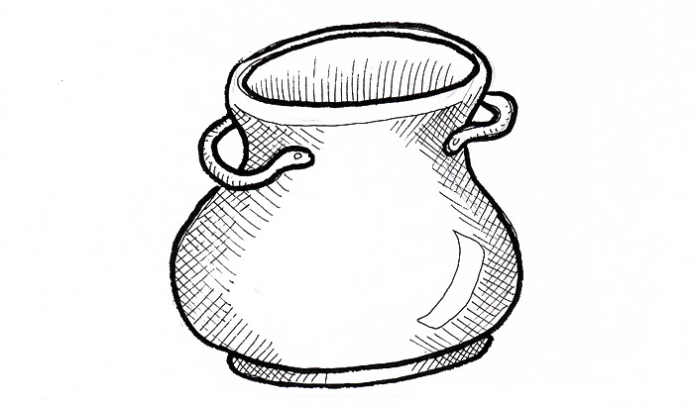
How many compound words can you make using the picture in the middle of the page? Draw a picture in a circle to make a new word and say the new word.

