Generating syllable words

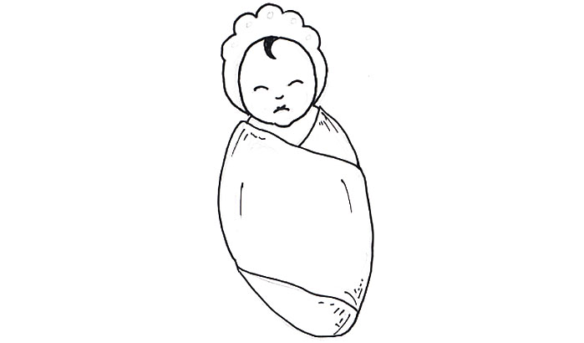
Look at the picture in the middle. Draw 3 pictures with the same number of syllables.

