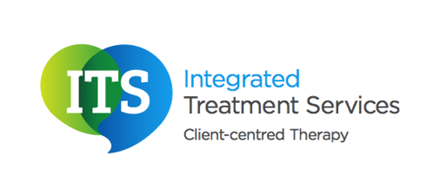

Social Communication Difficulties

What is social communication?

Social communication refers to the language skills that we use when we communicate and engage with other people. Such skills are important as they allow us to hold conversations, ask questions, make suggestions and request information in a socially acceptable manner. Social communication skills help us to initiate and maintain conversations with others and to take turns appropriately. During conversations we need to understand shared and assumed knowledge and how this can be used when communicating with other people. Understanding our own and other peoples’ non-verbal communication skills as well as using this appropriately (eg. eye contact, body language, personal space) is an essential part of

social communication.

Conditions associated with social communication difficulties?

There are a number of conditions associated with social communication difficulties. Some of the most common include: Autism Spectrum Condition, Down Syndrome, Learning Disabilities, Specific Language Impairment and Pragmatic Language Impairment.

How might individuals with social communication difficulties feel?

Children and adults with social communication difficulties may feel frustrated, as they may not understand and use the skills appropriately they may struggle to socialise with their peers. Therefore sometimes individuals may feel isolated. Children and adults with social communication difficulties may feel confused as they do not understand the ‘social norms’. This can sometimes result in low self-esteem and confidence.

What areas do social communication programmes target?

The areas that social communication programmes target will be dependent upon the individual. The Speech and Language Therapy will recommend the most suitable programme for the client. However some of the areas that may be targeted include:

Non-verbal communication – eye contact, body language, personal space

Conversational skills – listening skills, maintaining and initiative a conversation, turn taking, shared and assumed knowledge

Assertive behaviour – expressing feelings, making suggestions, requesting information.

Paralinguistic skills – intonation, volume

Who can implement social communication programmes?

A Speech and Language Therapist can implement a social communication programme. It is essential that the client practises the skills they have learnt with their parents, friends, school teachers/support assistants. If suitable, the therapist may recommend group therapy sessions as this will allow the client to practise social communication skills with other individuals with similar difficulties.