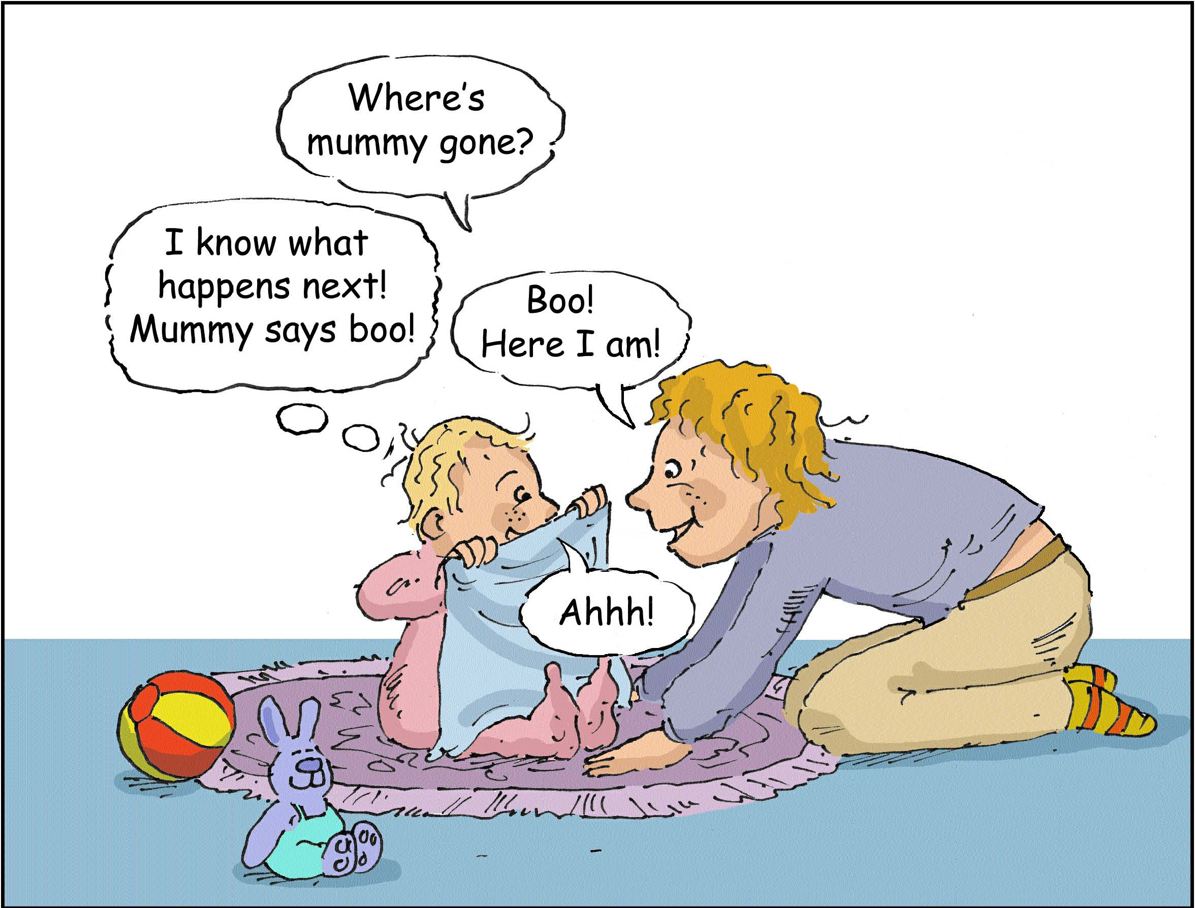

"Peep-Bo!"
Babies need you to talk to them a lot! They also need you to respond to their movements, facial expressions and noises.

So...be face-to-face. Get down to their level.

Copying the noises that babies make encourages them to babble and talk. Copying shows that you are listening and makes your baby feel good and special!

"Peep-Bo!"
Babies need you to talk to them a lot! They also need you to respond to their movements, facial expressions and noises.

So...be face-to-face. Get down to their level.

Copying the noises that babies make encourages them to babble and talk. Copying shows that you are listening and makes your baby feel good and special!

