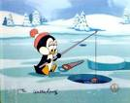 Going fishing

- Throw your line out

- Pull it back

- Throw your line out

- Pull it back

