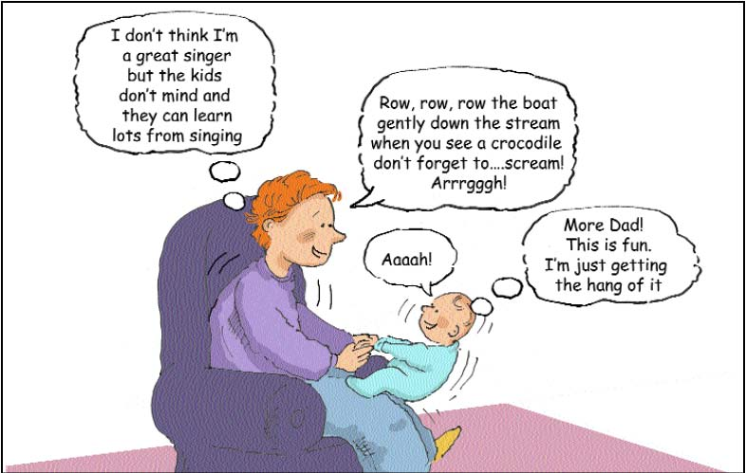

Sing together

There’s so much to learn through singing! Babies and children learn to listen and concentrate, especially to voices. Being face-to-face is best.

Don’t worry if you can’t sing in tune or remember all the words! Make up your own songs, or change the words so they are about what you and your child are doing.

Rhymes like "Humpty-Dumpty", "Two little Dickie Birds" and "Round and Round the Garden" still help children to learn to listen (and you don’t have to sing!). Children love rhymes with actions.

Children love to hear the same songs and rhymes several times over. You can ask "Again? Shall we sing/say it.

Sing together

There’s so much to learn through singing! Babies and children learn to listen and concentrate, especially to voices. Being face-to-face is best.

Don’t worry if you can’t sing in tune or remember all the words! Make up your own songs, or change the words so they are about what you and your child are doing.

Rhymes like "Humpty-Dumpty", "Two little Dickie Birds" and "Round and Round the Garden" still help children to learn to listen (and you don’t have to sing!). Children love rhymes with actions.

Children love to hear the same songs and rhymes several times over. You can ask "Again? Shall we sing/say it.

