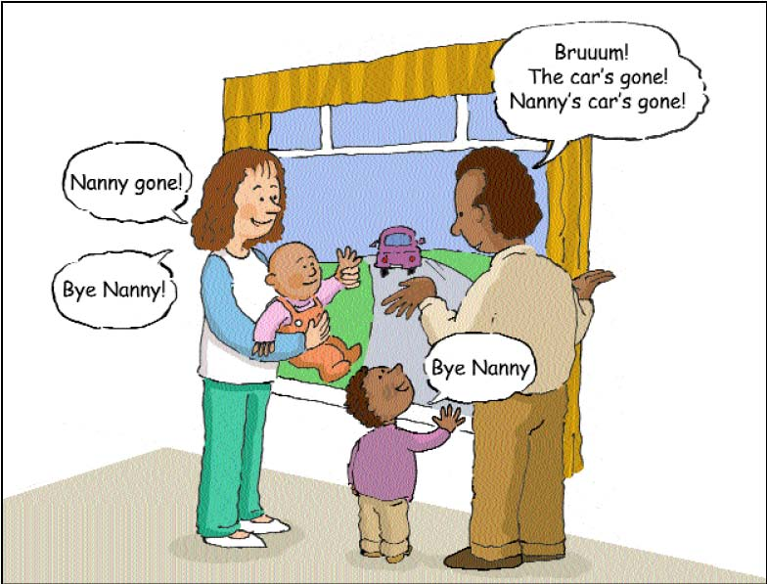

Use actions and noises
Using actions and noises alongside words helps children to learn those words.

In the same way that learning to wave will help your child to say "bye!"

