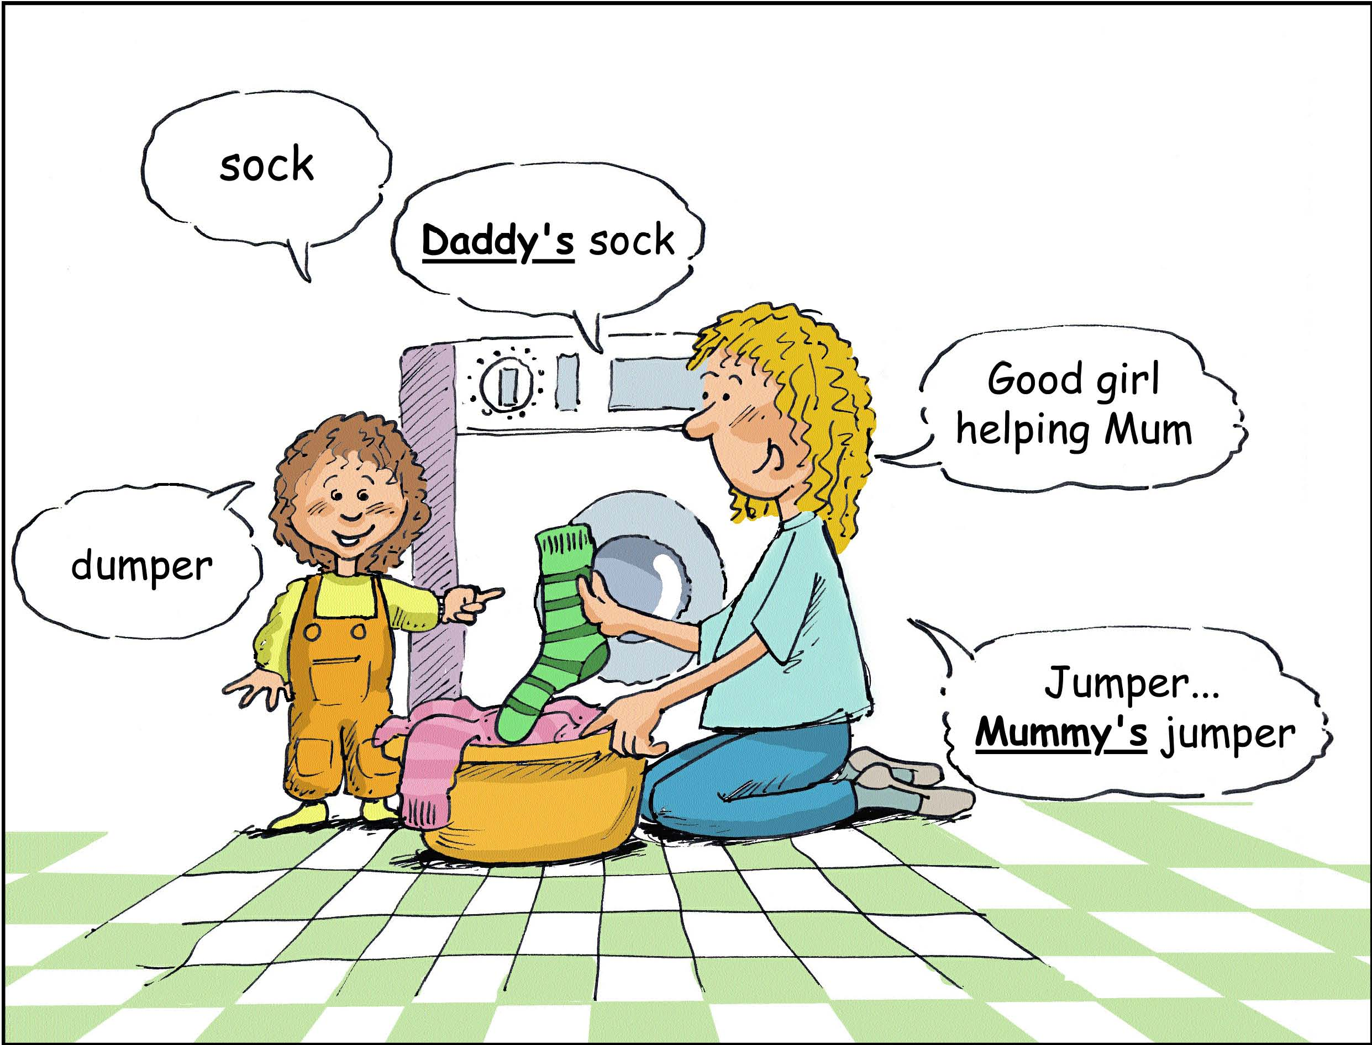

Talk about everyday things
Everyday tasks can be fun for your child when you let him/her help. It’s a great opportunity for talking and learning too!

Be face to face with your child, it will help him/her to listen to the words you say.

Help your child to learn a new word by adding a word to what he/she says.

Talk about everyday things
Everyday tasks can be fun for your child when you let him/her help. It’s a great opportunity for talking and learning too!

Be face to face with your child, it will help him/her to listen to the words you say.

Help your child to learn a new word by adding a word to what he/she says.

