Going to see the dentist

My name is _______________------

On Friday I am going to see the dentist. Her name is Mrs ______________--.



I will go in the car with Mummy and _____________.
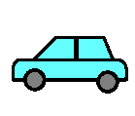

I will take my toothbrush and toothpaste with me.

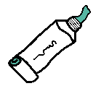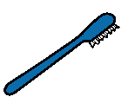

I will wait in the waiting room. I can sit with Mummy and _______________-:


Or if I want to I can play with the toys or books.

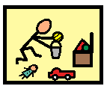
When it is my turn; me, Mummy and ______________ will walk into Mrs ______________room.

Mrs ______________ is the dentist. She has to wear a green mask.

Mrs ______________ will ask me to sit in the big blue chair.

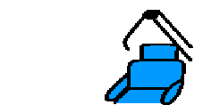

When I sit in the big blue chair Mummy will give me a sticker.

Then Mrs ___________ will ask me to open my mouth, and she will look at my teeth.



When I open my mouth Mummy will give me a sticker.

I might show Mrs __________________ how I brush my teeth.

If I get upset I can think about going home and:

playing with my trains

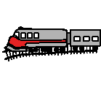
or playing in the paddling pool.

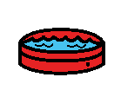

When Mrs _____________- has finished looking in my mouth I will get off the big blue chair and Mummy will give me another sticker.

Then I will go home with Mummy and ______________.

