Communication work sheet
Place the matching picture in each box, and repeat the sign/word for each. Or Put a spot/sticker in the correct when you hear the spoken name.

Chip   | Mum  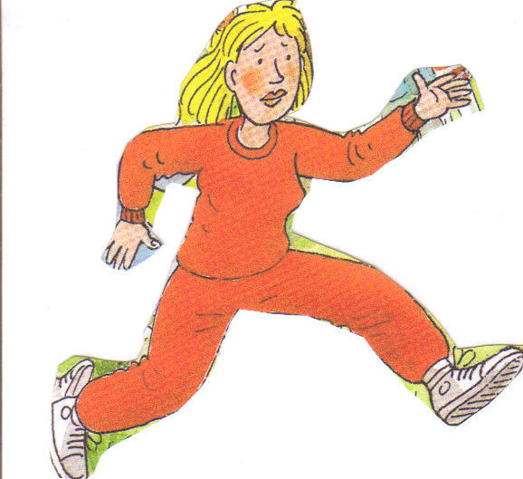 | Kipper  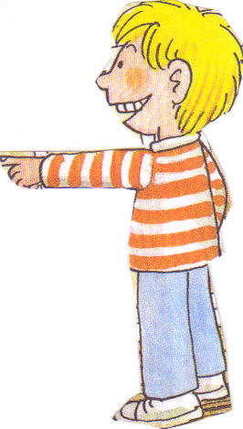 | Floppy  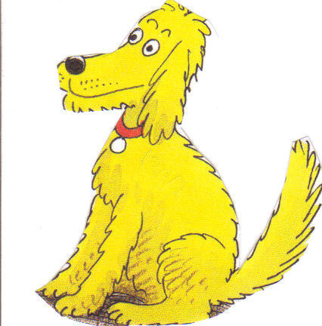 | Biff  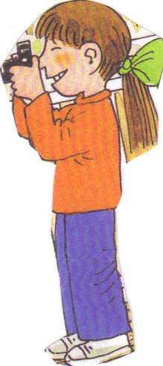 | Dad  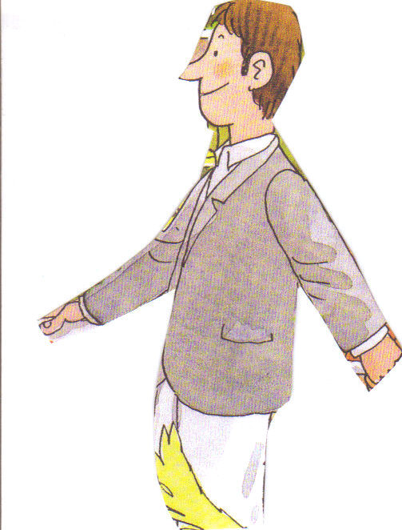
Name ____________________________ Date _________________________
Development:
Identify a particular character by the picture Practice saying/singing each character
Match the picture to a verbal instruction Photocopy your work to use as evidence

