Name: _______________________________________ Date: ______________________

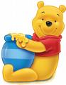

Use a set of cut up pictures. Suck up the picture using a straw and place on the sheet above.

