HARRY AND TOTO

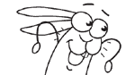
Harry
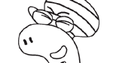
Toto
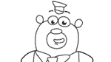
Barry
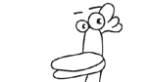
Carmen
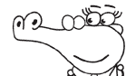
Crystal

Doris
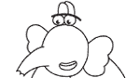
Eric
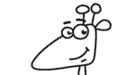
Gillie
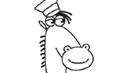
Horace
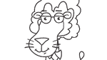
Lino
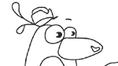
Patrick

BOB THE BUILDER


Bob

Pilchard
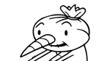
Spud
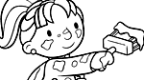
Wendy
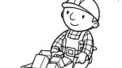
Wheelbarrow

BRUM
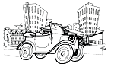
Brum
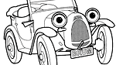
Brum
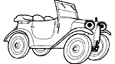
Brum

COME OUTSIDE

Pippin
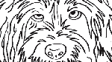
Pippin close-up
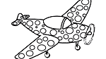
Plane

BIG BARN FARM
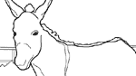
Dash
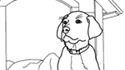
Digger
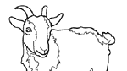
Gobo
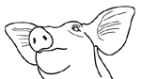
Petal
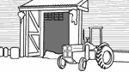
Big Barn

Stables

STORY MAKERS

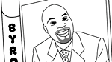
Byron
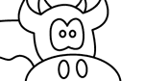
Blue Cow

Jackson



Jelly

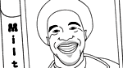
Milton

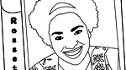
Rossetti

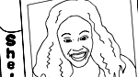
Shelley

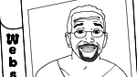
Webster

JACKANORY JUNIOR

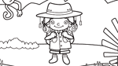
Explorer Ellie
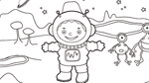
Spaceman Stan
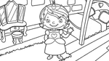
Princess Pemba
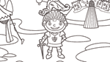
Sir Goodalot
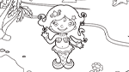
Mermaid Milly
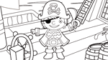
Pirate Patch
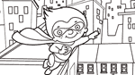
Super Sammy

GREEN BALLOON CLUB

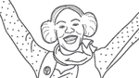
Sky

Ant
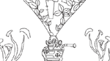
Green Balloon

Lily-Rose

Jay

Cat

BITS AND BOBS

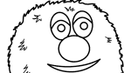
Bits
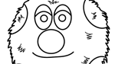
Bobs
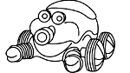
Trug

CLIFFORD


Clifford

Emily
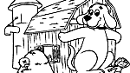
Hide and Seek

LUNAR JIM


Jim

Eco

Ripple

Rover
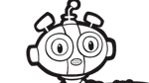
Ted
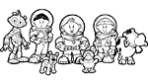
Lunar Jim and friends

LAZY TOWN

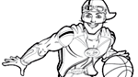
Sportacus

Stephanie
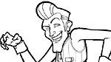
Robbie Rotten
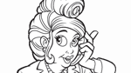
Bessie

Mayor
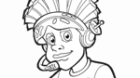
Pixel

Stingy

Trixie

Ziggy
POSTMAN PAT

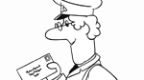
Postman Pat

Postman Pat and Jess
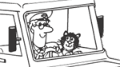
Postman Pat in his Van

UNDERGOUND EARNIE

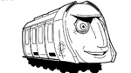
Bakerloo
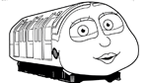
Circle
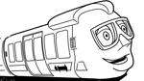
City
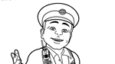
Ernie
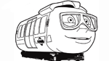
Hammersmith
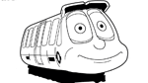
Jubilee

Millie
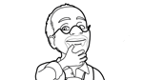
Mr Rails
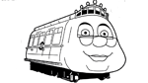
Victoria
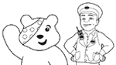
Underground Ernie and Pudsey

PEPPER PIG

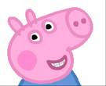

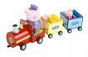

SPACE PIRATES

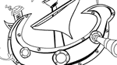
Guisto
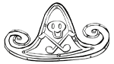
Hat

Zorst

Nina the Neurons


Nina
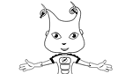
Belle
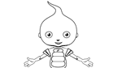
Bud
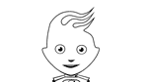
Felix
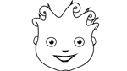
Luke
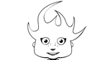
Ollie

JUNGLE BOOK

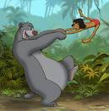



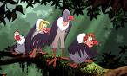

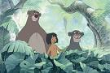

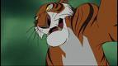

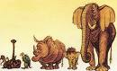

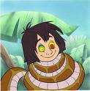

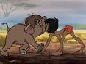

WHINNIE THE POOH

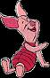

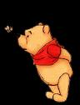

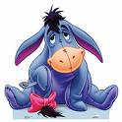

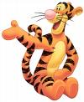

SHREK

