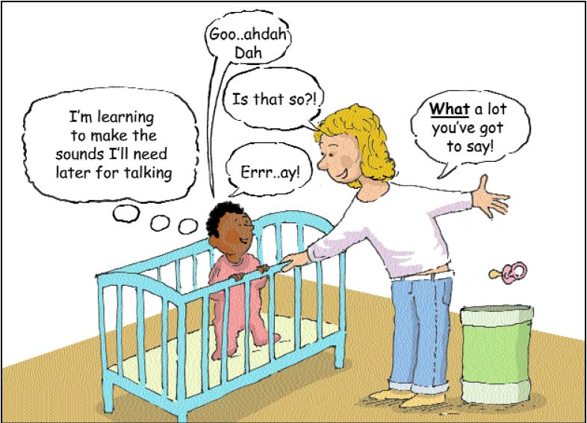

What about dummies?

Babies need to move their lips and tongue freely so that they can learn to make speech sounds.

Playing with sounds and babbling is an important part of learning to talk. Encourage your baby by talking back to him/her. Babies can learn about having a conversation when you take turns to talk.

Dummies can cause problems with teeth as well as making it difficult to say some sounds.

If your baby or child has a dummy, try to cut down on how often it is used. Take it out for talking! Think about when all the dummies can be "given away" to Santa or a "present fairy" or a baby or even a baby animal in exchange for a small toy.

Well done when you have got rid of all the dummies! Don’t back down! There may be tears for a day or two but the dummy will soon be forgotten.

What about dummies?

Babies need to move their lips and tongue freely so that they can learn to make speech sounds.

Playing with sounds and babbling is an important part of learning to talk. Encourage your baby by talking back to him/her. Babies can learn about having a conversation when you take turns to talk.

Dummies can cause problems with teeth as well as making it difficult to say some sounds.

If your baby or child has a dummy, try to cut down on how often it is used. Take it out for talking! Think about when all the dummies can be "given away" to Santa or a "present fairy" or a baby or even a baby animal in exchange for a small toy.

Well done when you have got rid of all the dummies! Don’t back down! There may be tears for a day or two but the dummy will soon be forgotten.

