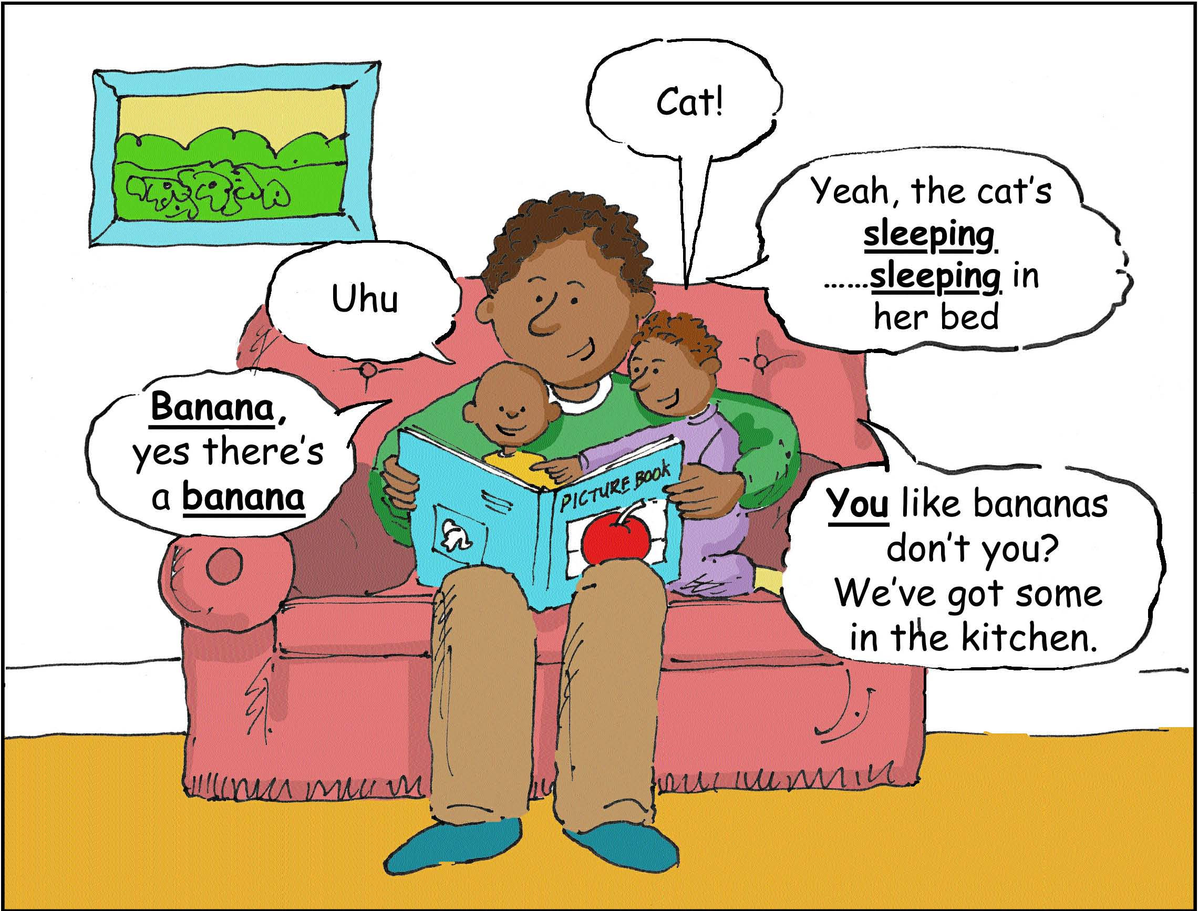

Share books – even with babies
You don’t have to read all the words in a book. You can just talk about the pictures your child is looking at.

You don’t even need to start at the beginning or look at all the pages.

Try making your own books, using photos or pictures cut from magazines. You can choose things you know your child is interested in.

