|  |
| --- |
| **Speech and Language Therapist Competency Framework** |
| My Summary of Evidence |
|  |
| This is an overview of the evidence I have gathered which illustrates I am a competent and professional Speech and Language Therapist. |
|  |
| **Name** |
| **Date** |
|  |

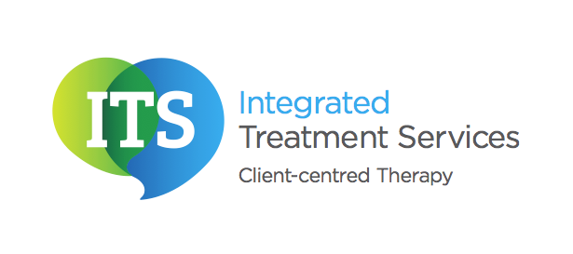

| Competencies to be met over the first 12 months of working | Evidence provided | **Date at which a competency is judged to have been achieved and by who** |
| --- | --- | --- |
| **Dimension 1: Communication** | |  |
| 1a)  Communicates with  people in a manner which  is consistent with their  level of understanding,  culture, background and  preferred ways of  communicating in order to  sustain positive  Relationships and enable constructive outcomes to be achieved. |  |  |
| 1b)  Facilitates access to  speech and language  therapy services by all  members of the community  through the use of interpreters, translation, culturally appropriate materials etc. |  |  |
| 1c)  Keeps accurate and  Contemporaneous  records |  |  |
| **Dimension 2: Personal and People Development** | | |
| 2a)  Identifies development needs and engages in continuous self- directed learning to promote professional development and quality of practice. |  |  |
| 2b)  Is involved in training other professionals, raising awareness of communication problems. |  |  |
| 2c) Provides peer support to newly qualified therapists. | Applies only to therapists with certified RCSLT membership (i.e. on completion of NQP transitional year) |  |
| 2d)  Provides clinical placements for speech and language therapy student | Applies only to therapists with certified RCSLT membership (i.e. on completion of NQP transitional year) |  |
| **DIMENSION 3: Health, Safety and Security** | | |
| 3a)  Provides safe care within the scope of practice, adhering to health and safety procedures and clinical guidance. |  |  |
| 3b)  Maintains all aspects of  patient/client confidentiality |  |  |
| **DIMENSION 4: Service Improvement** | | |
| 4a)  Is aware of current  clinical audit findings and  incorporates these into  practice |  |  |
| **DIMENSION 5: Quality** | | |
| 5a)  Understands and follows  the clinical administration  processes. |  |  |
| 5b)  Works as part of a  multidisciplinary team and  understands the roles of  other members of the team. |  |  |
| 5c)  Accesses support from  mentors/specialists for  complex cases. |  |  |
| 5d)  Manages and prioritises demands involved in meeting the needs of the caseload. |  |  |
| 5e)  Manages time effectively to  balance clinical and non  clinical responsibilities. |  |  |
| 5f)  Is aware of and adheres to  current legislation,  incorporating this into  practice. |  |  |
| **DIMENSION 6: Equality and Diversity** | | |
| 6a)  Acts in ways that  acknowledges people’s  rights to make their own  decisions and recognises  their responsibilities. |  |  |
| 6b)  Acts in ways that are non  discriminatory and  respectful of others’ beliefs  and perspectives. |  |  |
| **DIMENSION 7: Assessment and Care Planning to meet Health and Wellbeing Needs** | | |
| 7a)  Identifies and collects  relevant information  through appropriate formal  and informal assessment,  including discussion with  the client/carer. |  |  |
| 7b)  Makes a clinical  judgement/diagnosis in  relation to the nature and  extent of less complex  speech and language  therapy difficulties. |  |  |
| 7c)  Interprets the  assessment information  and produces an  appropriate evidence  based therapy  management plan,  involving key people in the  client’s environment. |  |  |
| 7d)  Makes and justifies independent decisions on **less complex patient**/client care. |  |  |
| 7e)  Refers to other  professionals in a timely  and appropriate way. |  |  |
| 7f)  Uses the Royal College of  Speech and Language  Therapists’ guidelines  within practice. |  |  |
| 7g)  Is aware of current critically  appraised research and is  able to use it to inform  practice. |  |  |
| **DIMENSION 8: Health and Wellbeing - Interventions** | | |
| 8a) Agrees with relevant others and implements an appropriate therapy management plan based on functional outcomes and clearly defined goals, including an understanding and use of preventative strategies. |  |  |
| 8b) Prepares, evaluates and modifies aspects of the therapy management plan to be carried out by key agent(s) of change taking into account their knowledge and abilities. |  |  |
| 8c) Continuously evaluates the efficacy of the therapy management plan, and modifies it as appropriate. |  |  |
| 8d) Discharges client appropriately, agreeing a point of closure with the client/carer and informing other professionals. |  |  |
| 8e) Prepares, evaluates and modifies aspects of the therapy management plan for speech and language therapy assistants. | Applies only to therapists with certified RCSLT membership (i.e. on completion of NQP transitional year) |  |