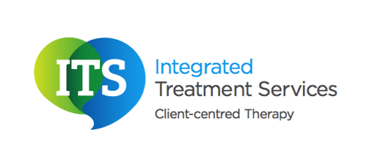

Understanding Autism Spectrum Condition

What is Autism?

Autism is a lifelong condition. Autism affects how individuals communicate, interact and relate to other people and the world around them. Individuals with Autism have three main areas of difficulty and these are called the ‘triad of impairments’.

**Social Interaction**- difficulties understanding emotions and feelings

**Social Imagination** – difficulties with abstract concepts, understanding and predicting behaviours and unfamiliar situations

**Social Communication** – difficulties understanding and using language

In a diagnosis, each of these three areas will be considered. Other areas that may be considered during a diagnosis are: routines, sensory difficulties, specific interests and any other co-existing conditions.

Why is Autism a ‘spectrum condition’?

Whilst individuals may share some symptoms, ultimately everyone is affected differently and to varying degrees. The term Autism spectrum condition covers a group of conditions, as well as Autism it also includes: Asperger syndrome, pervasive developmental disorder not otherwise specified and childhood disintegrative disorder.

Autism is also referred to as Autism spectrum disorder (ASD) by some professionals. Ultimately the two terms mean the same, but Autism spectrum condition is the preferred term by most professionals.

What causes Autism?

At present, the cause of Autism spectrum condition is unknown. Research however does indicate that certain genetic and environmental factors may contribute to Autism spectrum condition. Autism is not caused by an individual’s upbringing.

Currently there is no ‘cure’ for Autism spectrum condition. However there are a range of education and behavioural programmes available that have been developed by specialists that can be effective in developing the skills of individuals with Autism spectrum condition.