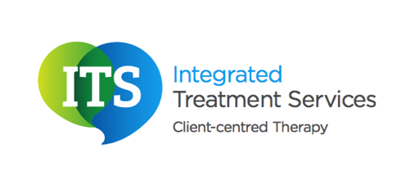

Diagnosing Autism spectrum condition – involving health professionals

Who can diagnose Autism spectrum condition?

To receive an official diagnosis of Autism spectrum condition, an individual needs to have a formal assessment. An assessment is carried out by health professionals. The health professional chosen to lead on the assessment is dependent on the specific needs of the individual having the assessment. At Integrated Treatment Services we have two assessment routes: a single professional assessment and a multi professional assessment. Our assessments are carried out by highly skilled therapists.

Who is involved in the diagnosis?

The professionals involved in the diagnosis is dependent on the assessment and diagnostic process that has been chosen for the individual.

Individuals with a complex presentation may need a multi professional assessment. Therefore all of the professionals who are involved with the individual will be invited to be part of the diagnosis. A consultant and a therapist (speech and language therapist, occupational therapist, physiotherapist, music therapist, art therapist, play therapist or a drama therapist) will always be part of this route. Both statutory and independent professionals are included in the multi professional assessment.

Some individuals may only require an assessment by one professional. This could be facilitated by a speech and language therapist, occupational therapist, physiotherapist, music therapist, art therapist, play therapist or a drama therapist.

Regardless of the assessment route that is selected, the family and the client will always be an integral part of the assessment process.